TASK NO 5

NAME = SYED HAIM ALI

ROLL NO = 014

SECTION = BSSE-4A

1)
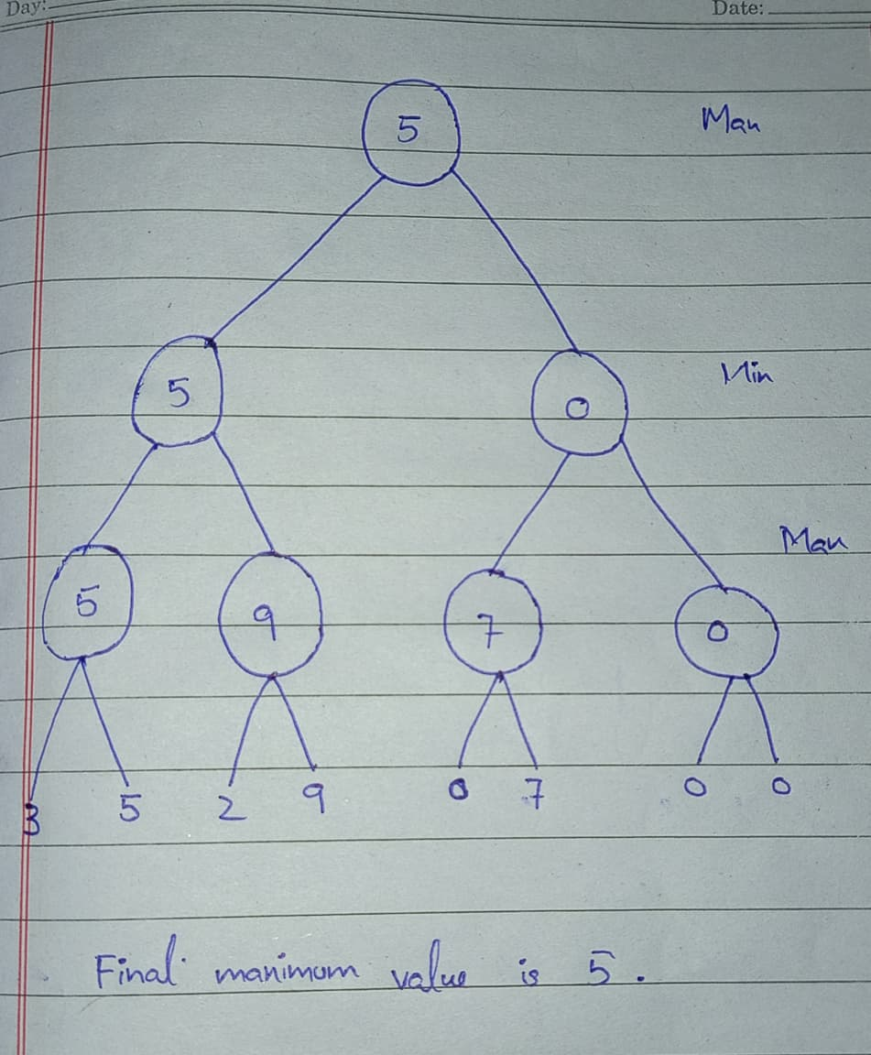

Conclusion:
In this task, I applied the Minimax algorithm to the given game tree. First, I calculated the values of the MAX nodes by selecting the maximum value from each pair of leaves. Then, I calculated the MIN nodes by selecting the minimum value. Finally, the root MAX node selected the greater value.The final Minimax value is 5, so MAX chooses the left subtree as the optimal move.

